**IT24102920**

**Balasuriya W.N.A**

**IT2120 - Probability and Statistics – Lab Sheet 08**

**Exercise**

01)

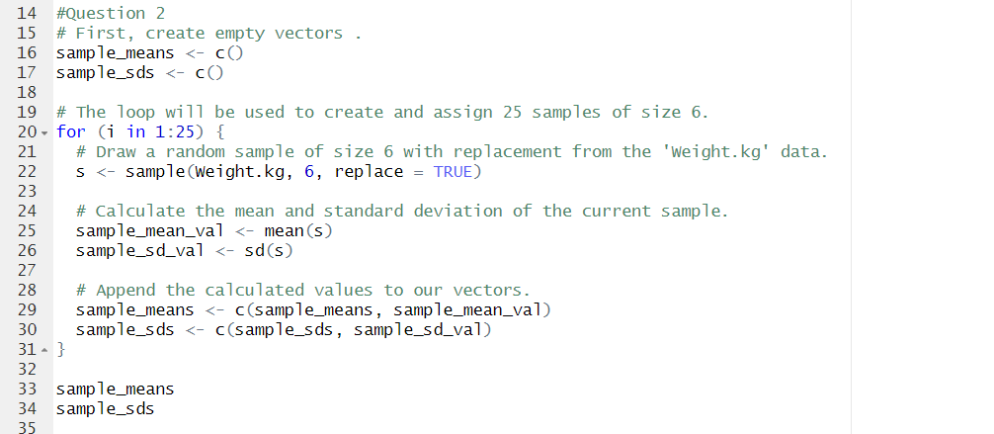02)

03)

